Project Design Phase-II
Data Flow Diagram & User Stories

Date | 25 September 2026
Team ID | 6ab4bf896f290be8a6b413e7
Project Name | AI WeatherWise API
Maximum Marks | 4 Marks

Data Flow Diagrams:
A Data Flow Diagram (DFD) is a traditional visual representation of the information flows within a system. A neat and clear DFD can depict the right amount of the system requirement graphically. It shows how data enters and leaves the system, what changes the information, and where data is stored.

User Stories
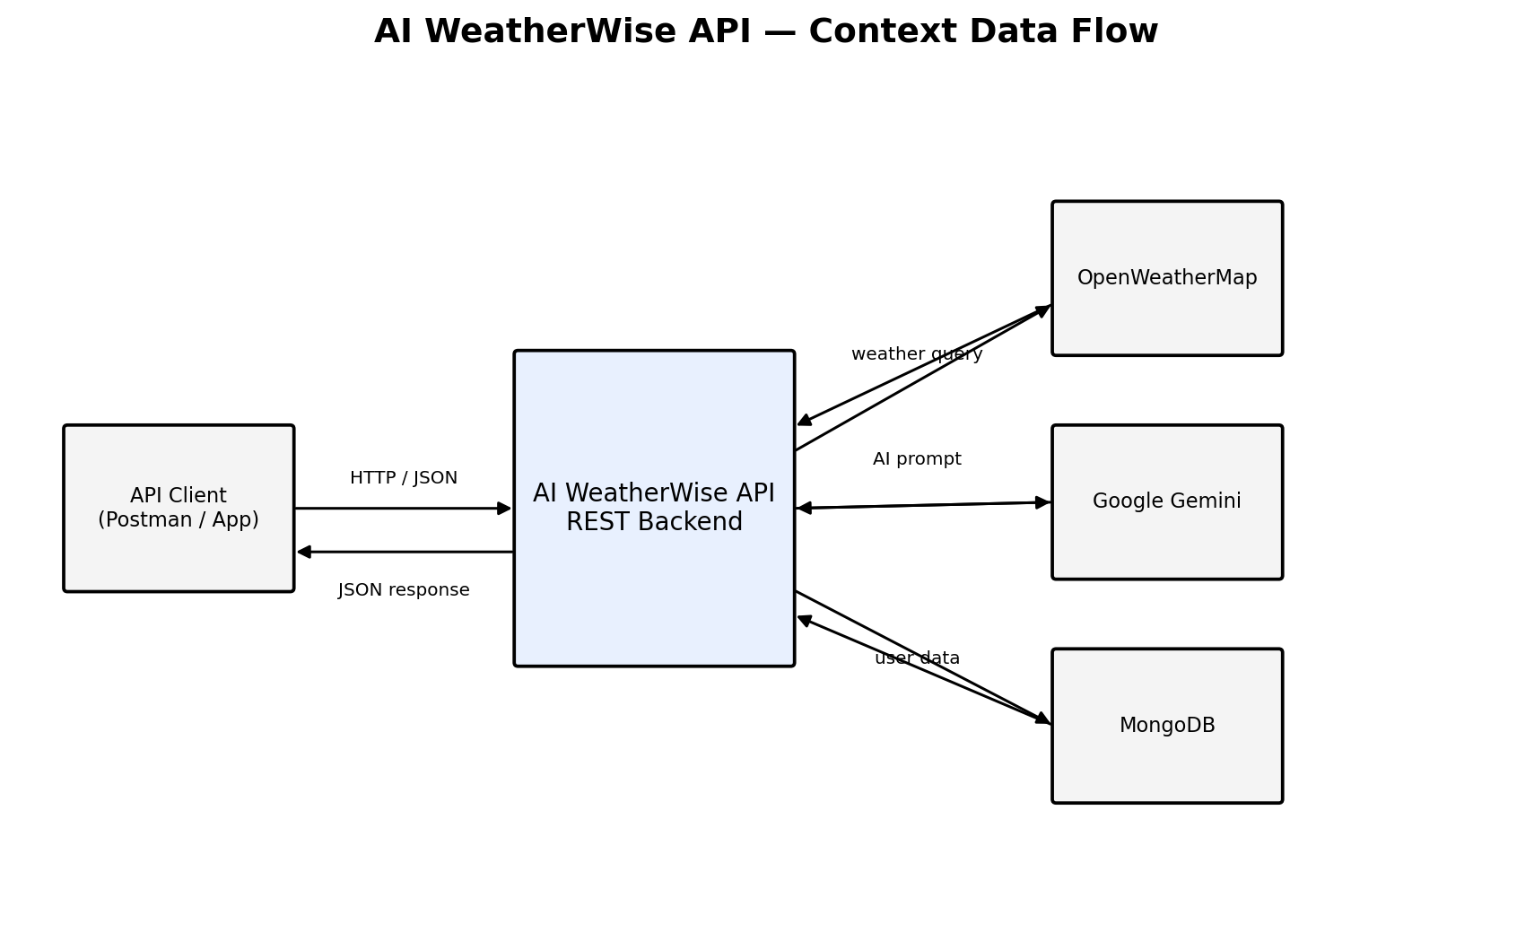
Figure 1: Level-0 Data Flow Diagram of the AI WeatherWise API
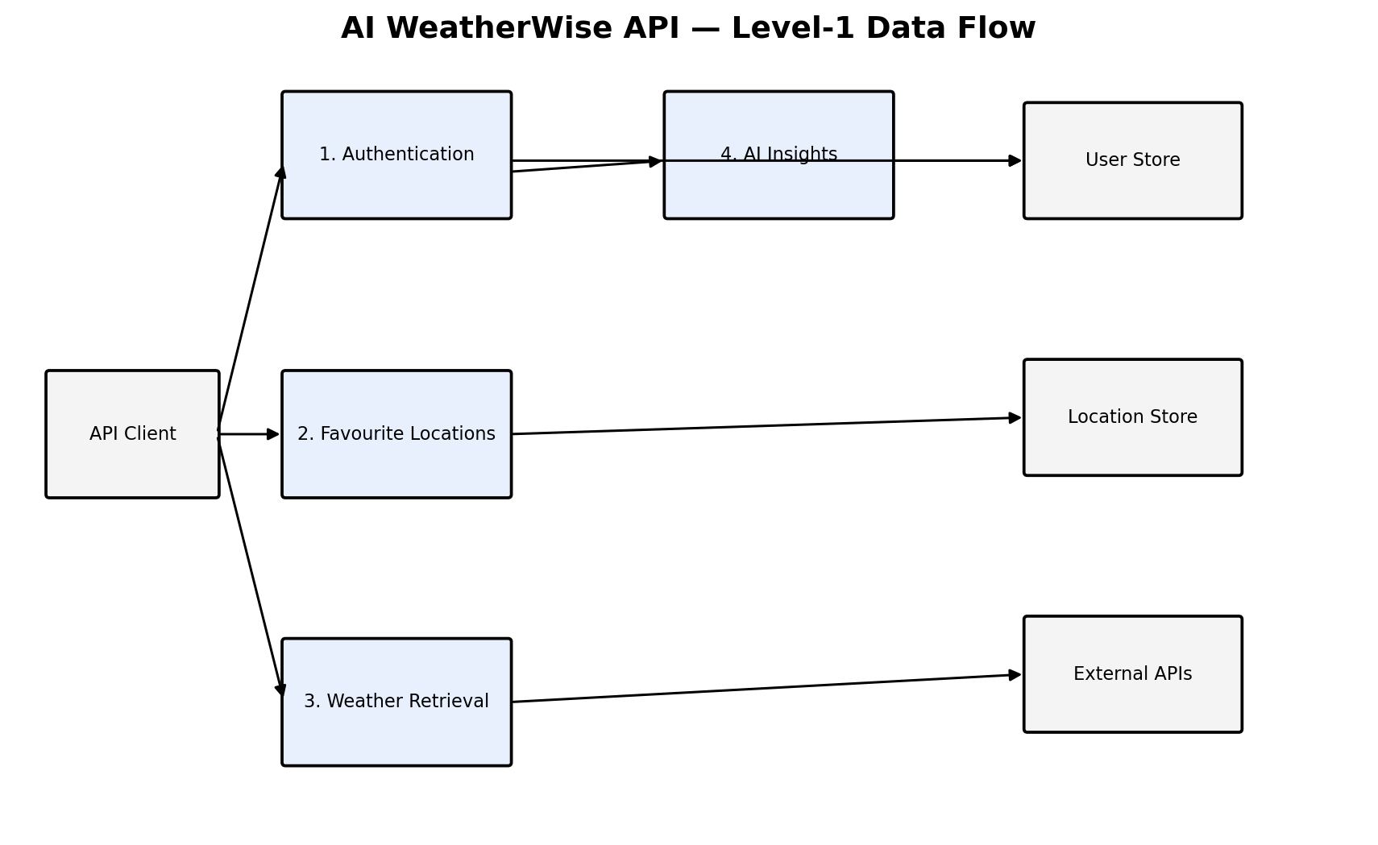
Figure 2: Level-1 Data Flow Diagram of the AI WeatherWise API
Use the below template to list all the user stories for the product.
User Type | Functional Requirement (Epic) | User Story Number | User Story / Task | Acceptance criteria | Priority | Release
Customer (Mobile user) | Registration | USN-1 | As a user, I can register for the application by entering my email, password, and confirming my password. | I can access my account / dashboard | High | Sprint-1
 |  | USN-2 | As a user, I will receive confirmation email once I have registered for the application | I can receive confirmation email & click confirm | High | Sprint-1
 |  | USN-3 | As a user, I can register for the application through Facebook | I can register & access the dashboard with Facebook Login | Medium | Sprint-1
 |  | USN-4 | As a user, I can register for the application through Gmail |  | Medium | Sprint-1
 | Login | USN-5 | As a user, I can log into the application by entering email & password |  | High | Sprint-1
 | Dashboard
Customer (Web user)
Customer Care Executive
Administrator

Table-6: User Stories
User Type | Functional Requirement (Epic) | User Story Number | User Story / Task | Acceptance criteria | Priority | Release
User (API client) | Registration | USN-1 | As a user, I can register for the application by entering my name, email and password. | A new account is created, and I receive my details and a JWT token (HTTP 201). Registration is rejected if a field is missing, the password has fewer than 6 characters, or the email already exists. | High | Sprint-1
 | Login | USN-2 | As a user, I can log into the application by entering my email and password. | I receive my details and a JWT token. Invalid credentials return HTTP 401. | High | Sprint-1
 | Profile | USN-3 | As a user, I can view my profile details. | When I send a valid Bearer token, I receive my ID, name, email and creation date, without my password. | Medium | Sprint-1
 | Favourite Locations | USN-4 | As a user, I can add a city and country to my favourite locations. | The location is saved under my account (HTTP 201). A duplicate of an existing favourite (ignoring letter case) is rejected. | Medium | Sprint-1
 | Favourite Locations | USN-5 | As a user, I can view all my favourite locations. | I receive the count and the list of my saved locations, with the newest first. | High | Sprint-1
 | Favourite Locations | USN-6 | As a user, I can update a favourite location. | The city and country are updated. The request is rejected if the location does not exist, belongs to another user, or duplicates another favourite. | High | Sprint-2
 | Favourite Locations | USN-7 | As a user, I can delete a favourite location. | The location is removed from my favourites. The request is rejected if the location does not exist or belongs to another user. | High | Sprint-2
 | Current Weather | USN-8 | As a user, I can get the current weather of a city. | I receive the temperature, humidity, wind speed and condition. An unknown city returns “City not found”. | High | Sprint-2
 | AI Weather Summary | USN-9 | As a user, I can get a natural-language summary of the weather. | When I provide city, temperature, humidity and condition, I receive a short summary. Missing fields return HTTP 400. | High | Sprint-3
 | AI Weather Recommendation | USN-10 | As a user, I can get personalised recommendations for the weather. | When I provide temperature and condition, I receive practical suggestions on clothing, hydration and activities. | High | Sprint-3
Developer / Tester | Fallback Mode | USN-11 | As a developer or tester, I can use all endpoints without external API keys. | With placeholder keys, the API returns mock weather data and rule-based AI text, so that every endpoint can be verified. | Medium | Sprint-3

